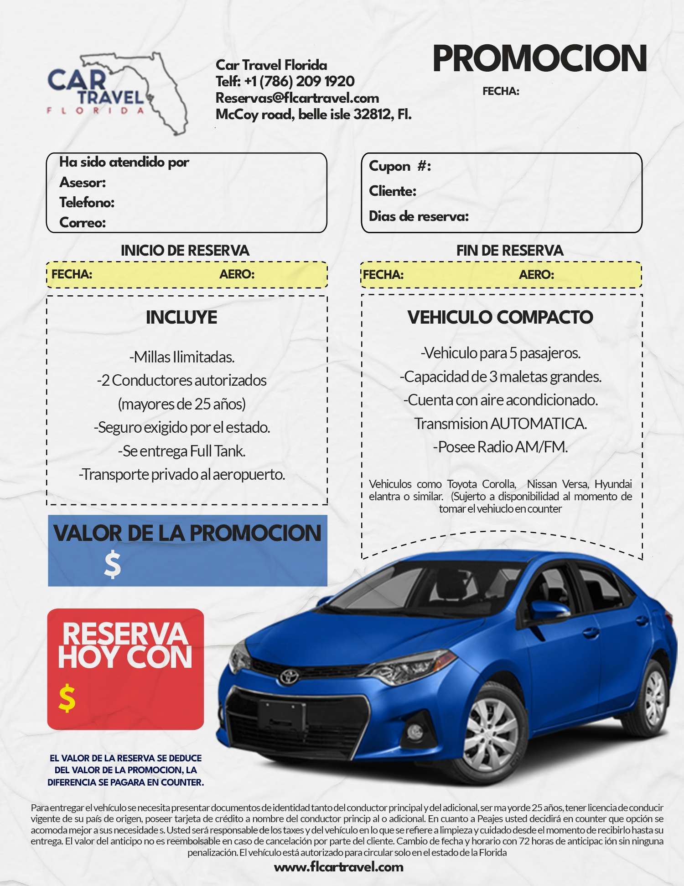
.
13778057
Juan David Rojas

Camila Rondon
+1 (323)657-5273
Camila.rondon@flcartravel.com

140.00
419.86
92.77
MCO
08/2/2024
MIA
06/20/2024
07/19/2024

