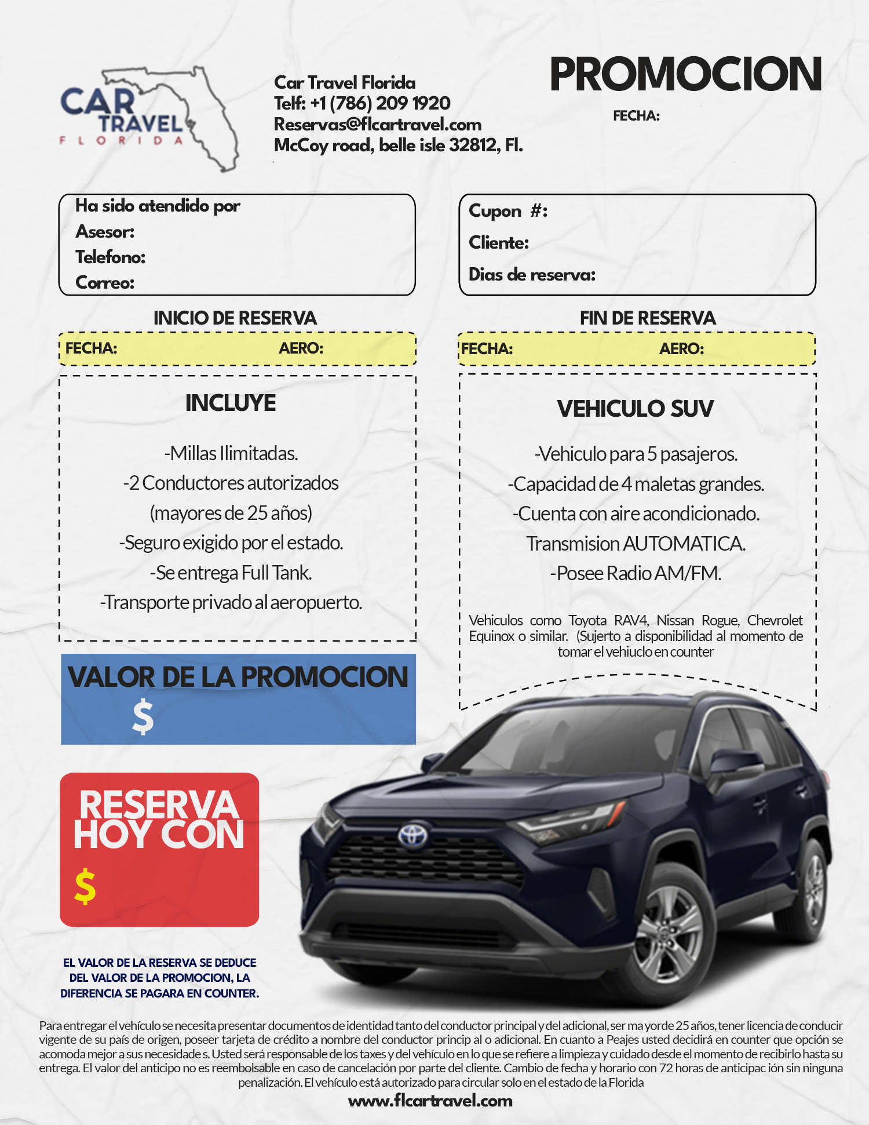
MIA
Camila Rondón
+1 (323) 657-5273
Camila.rondon@flcartravel.com

150.00
474.87
9
MIA
07/15/2024
07/2/2024
13760441
Gustavo Sena
13
06/14/2024

